LOW CODE APPLICATION DEVELOPMENT USING ZOHO CREATOR

NAME:DIVYA S
ROLL NO:240701128

EXPERIMENT:1
SETTING UP A ZOHO CREATOR ACCOUNT AND EXPLORING THE PLATFORM ARCHITECTURE AND INTERFACE.
Aim
To create a Zoho Creator account, develop a sample Order Management Application, and explore the platform's architecture, interface, forms, reports, and dashboards to understand how low-code application development works.
Setting Up Zoho Creator
Create a Zoho Creator Account
- Open the Zoho Creator website.
- Click Sign Up.
- Register using an email address or Google account.
- Verify the account through the email verification link.
- Log in to access the Zoho Creator dashboard.
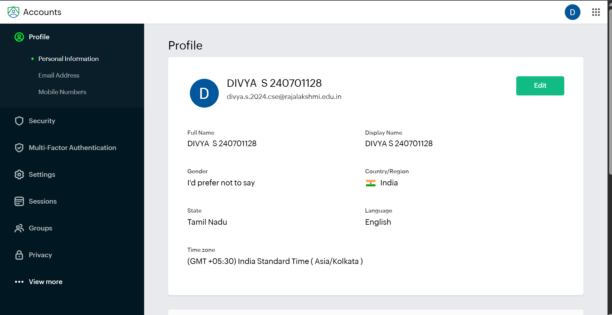

Create a Sample Application
Application Name: Order Management App
The Order Management App is developed using Zoho Creator to simplify the process of managing customer orders. It enables users to record customer information, track product orders, monitor order status, and manage the delivery process. The application stores all order details in a centralized database and provides reports and dashboards for easy monitoring and analysis.
The application helps users to:
- Add new customer orders.
- Update existing order details.
- View and manage all customer orders.
- Track the progress of each order.
- Monitor order status from confirmation to delivery.
- Analyze order data using reports and dashboards.
Modules Included
- Customer Information
- Order Details
- Order Status
- Reports
- Dashboard

Order Form
Description
The Order Form is used to enter and manage customer order details. It allows users to record the customer's first and last name, product ordered, quantity, order date, estimated delivery date, current order status, next action, and additional notes. The form validates the entered data and stores it securely in the Zoho Creator database for future reference and reporting.

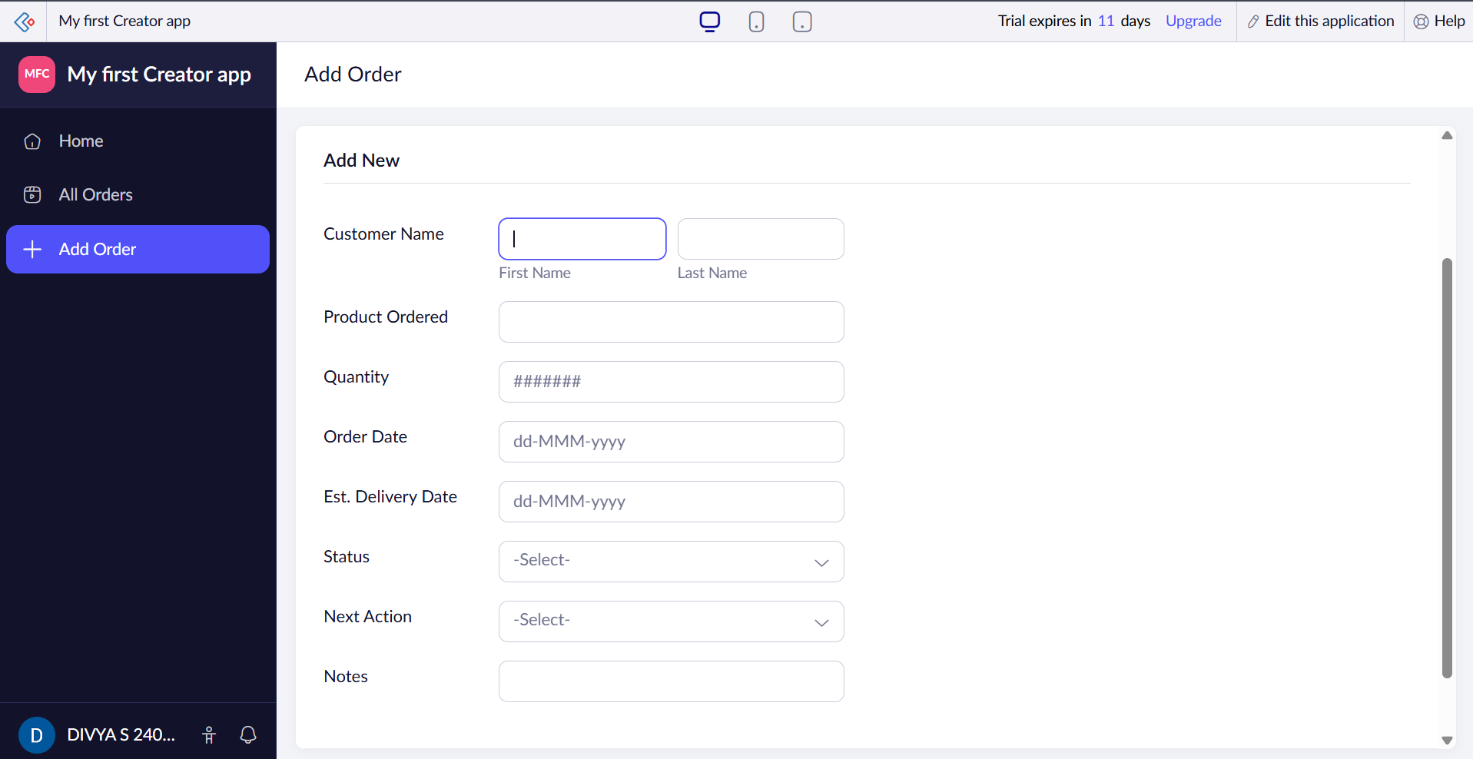

Report
Description
The Report page displays all customer orders in a structured table format. It includes customer name, product ordered, quantity, order date, estimated delivery date, order status, next action, and notes. Users can search, filter, sort, edit, or delete records easily. Reports provide quick access to order information, making it simple to track order progress and manage customer data efficiently.
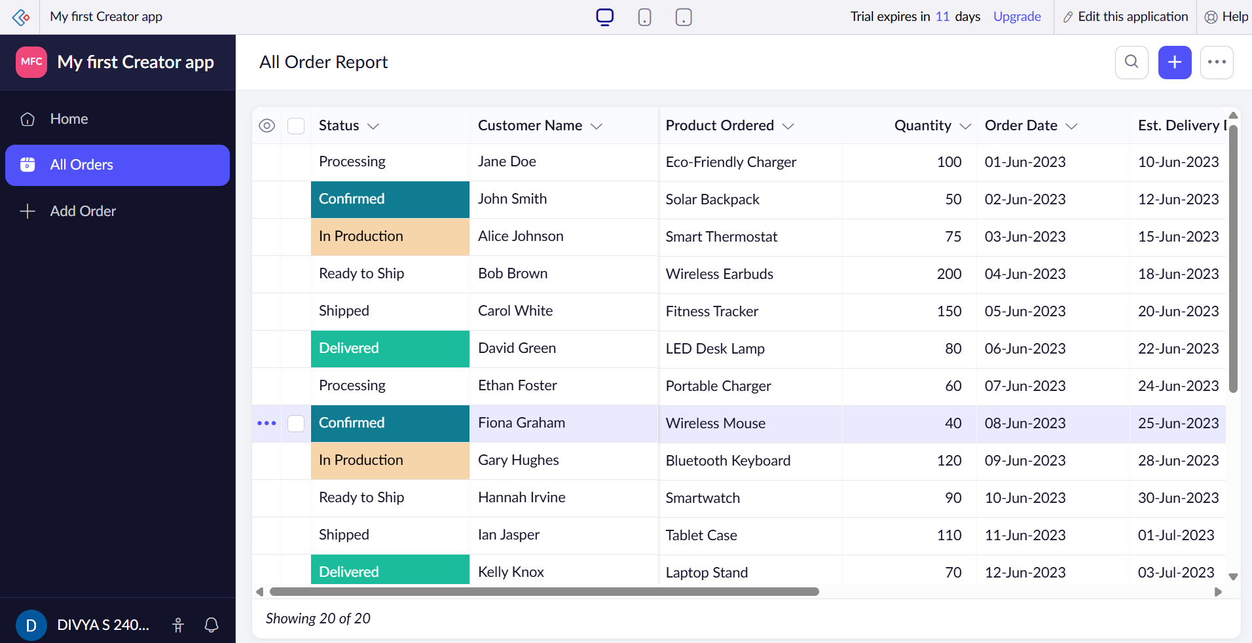

Dashboard
Description
The Dashboard provides a visual summary of the Order Management App using KPI cards and charts. It helps users quickly monitor the overall status of customer orders.
The dashboard displays:
- Total Orders
- Orders Delivered
- Orders Confirmed
- Ready to Ship Orders
- Order Status Funnel Chart, showing the number of orders at different stages such as Confirmed, Processing, Delivered, Shipped, Ready to Ship, and In Production.
- Quantity Analysis Bar Chart, showing the quantity of products ordered for performance analysis.
The dashboard enables users to monitor order progress, identify pending orders, analyze order quantities, and make informed business decisions through graphical reports.
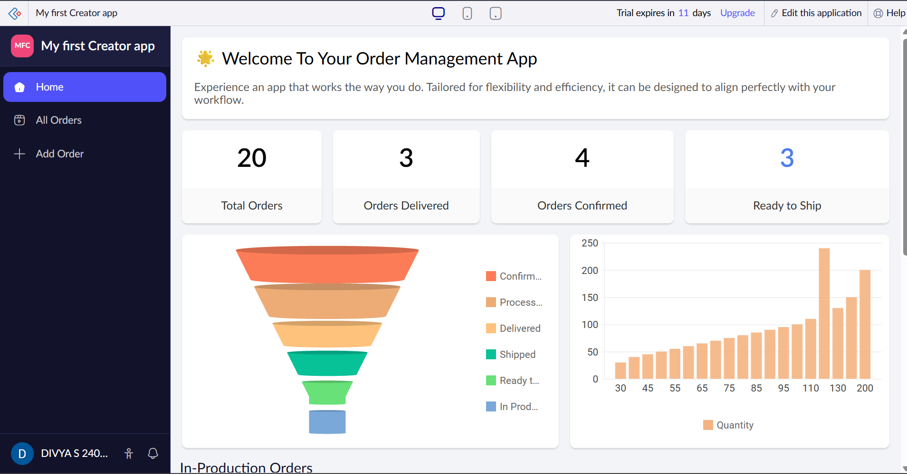
Explore the Architecture and Interface
Zoho Creator Architecture
Zoho Creator is a cloud-based low-code application development platform that enables users to build business applications using visual tools with minimal coding. It provides an integrated environment for designing forms, storing data, automating workflows, generating reports, and creating dashboards.
Architecture Components
1. Presentation Layer (User Interface)
The presentation layer provides an interactive interface where users can access applications, fill forms, view reports, and analyze dashboards. It is designed to work on desktops, tablets, and mobile devices.
2. Application Layer
This layer contains the application's business logic. Developers can create workflows, validation rules, approval processes, and automation using Zoho's Deluge scripting language.
3. Data Layer
Zoho Creator automatically creates and manages a secure cloud database. All records entered through forms are stored, updated, and retrieved without requiring manual database management.
4. Automation Layer
This layer performs automated tasks such as:
- Sending email notifications
- Updating records automatically
- Running scheduled workflows
- Triggering actions based on user input
- Performing calculations and validations
5. Analytics Layer
The analytics layer generates reports, charts, KPIs, and dashboards to help users monitor application performance and make informed decisions.
6. Cloud Deployment
Applications are hosted on Zoho's cloud platform, allowing secure access from anywhere through web browsers or mobile devices without additional installation.
Zoho Creator Interface
The Zoho Creator interface provides a simple and organized workspace for creating, managing, and deploying applications.
Main Workspace
Applications
The Applications section displays all applications created by the user. Each application can be opened, edited, shared, or managed. In this experiment, the applications displayed are:
- My First Creator App (Order Management App)
Search Bar
The search option allows users to quickly locate applications within the workspace.
Create Application
The Create Application button is used to develop a new application using templates, AI assistance, or a blank application.
Sidebar Components
The left navigation panel provides access to different services and management options.
Develop Section
Microservices
The Microservices section is used to build and manage reusable backend services and APIs that can be integrated with Zoho Creator applications.
DEPLOY Section
Environments
Allows developers to manage different deployment environments such as Development, Testing, and Production for safe application deployment.
Mobile
Provides options to publish and access Zoho Creator applications on Android and iOS devices.
Portal
Used to create secure customer or employee portals where external users can log in and interact with the application.
MANAGE Section
Users
Manages application users, assigns roles and permissions, and controls access to different application features.
Organization
Displays organization details, user accounts, teams, and administrative settings for managing the Zoho Creator workspace.

Governance
Provides security policies, compliance settings, and access control to ensure safe application management.
Metrics
Displays application usage statistics, performance data, storage utilization, and user activity for monitoring the application.
Operations
Allows administrators to monitor application health, manage deployments, troubleshoot issues, and perform maintenance activities.
Billing
Displays subscription plans, payment history, license information, trial period details, and billing management options.
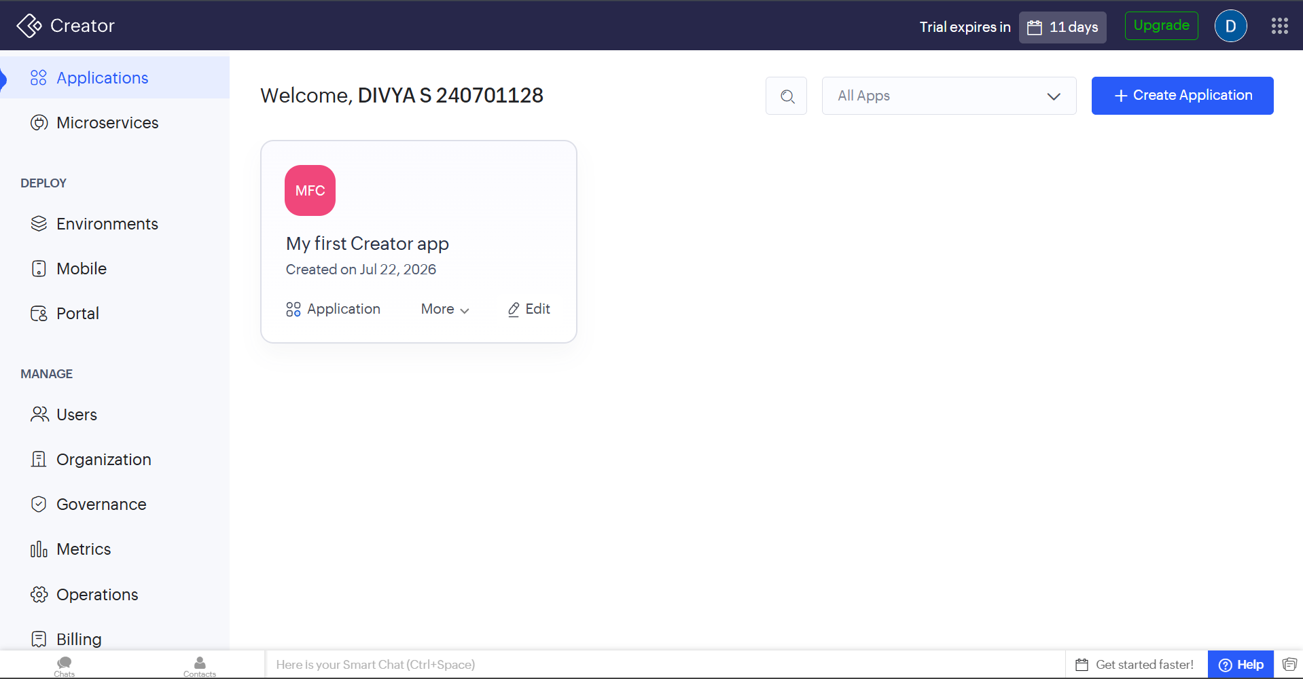
Result
Successfully created an Order Management App using Zoho Creator and explored its architecture and interface. The application includes an order entry form, report, and dashboard for managing customer orders. The platform's low-code features, such as automatic database creation, drag-and-drop interface, workflow automation, reports, dashboards, and cloud deployment, were studied. The experiment demonstrated that Zoho Creator enables rapid application development with minimal coding while providing efficient tools for data management, reporting, and business process automation

